VMs with Misconfigured Name

# Overview

It provides a report of VMs with misconfigured Name .It lists out all the VMs which do not follows a provided pattern in their name which should be [OC-VMname-number].

# Goal

It is prepared to ease out the process of analyzation of VMs name.

# Solution /Logic design

Fetch all the business groups

vcacCAFEHost

For each BG

Fetch its resources and OC value if exists

For each resource

If(resources.name.substring(0,4) == OC)

Get the vm name,its ip address and blueprint name

Do nothing

Vmname.match(regular expression)

# if yes

# 

# if no

Array.push(vmname,bg,oc,blueprint,ipaddress)

write data in a file through action ’WriteDataToFile’ and send with the mail through workflow ’send Mail’

end

# properties included

* VM Name – Name of the VM

Dependencies

# Related Actions

* WriteDataToTheFile – It writes the requested data to the provided file.
* ValidateEmail – It validates the mail Address.

# Related Configuration elements

* VcacHost – host through which VRO connect with IAAS services of VRA to fetch the required data.
* VcacCafeHost – host through which VRO connect with VRA to fetch the required data.
* SmtpHost – with which one will be able to connect to the server to send the mail.
* CcAddress – it includes other member’s mail address to whom requester wants to send the mail.
* smtpPort - with which one will be able to connect to the server to send the mail.
* fromName - name of the organization
* fromAddress - address of the organization

# Related Workflows

* Send Mail – It sends the mail to the sender’s address.

# Attributes

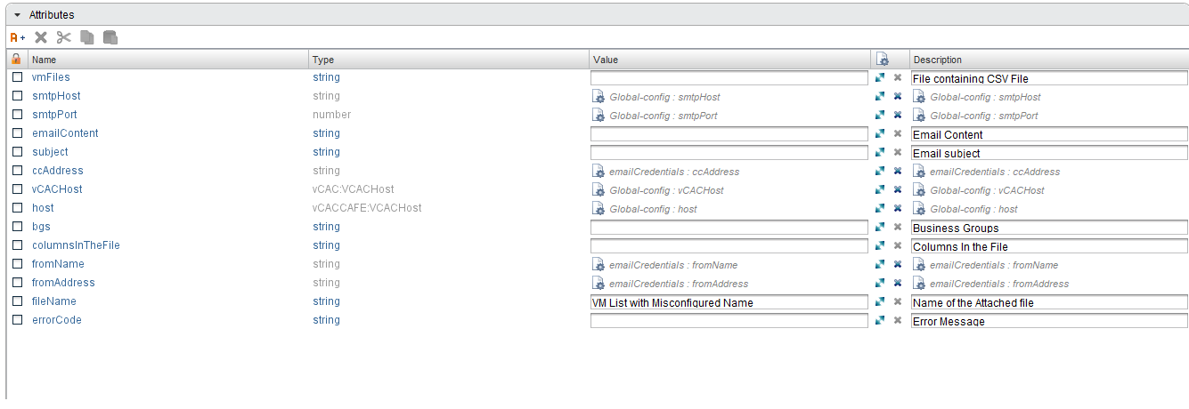

# Inputs

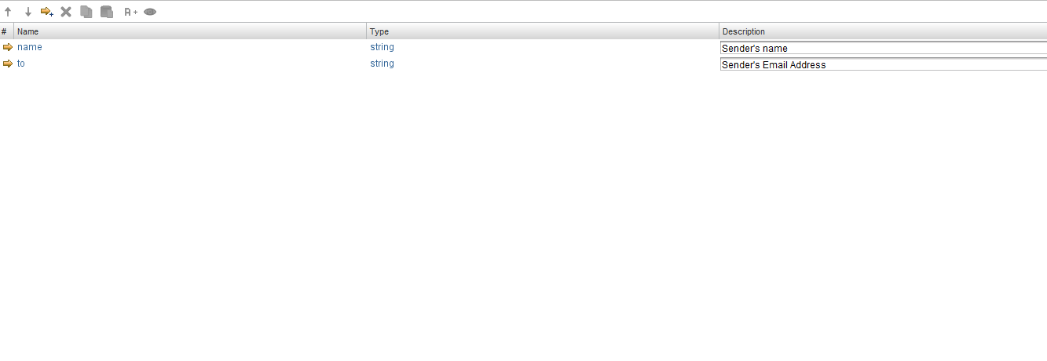

# Future scope

Nothing till yet